WHEN TO KEEP YOUR KIDS HOME:
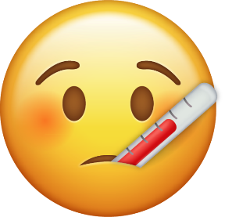
An oral temperature of 101 degrees or greater. (Students may need to stay home at a lower temperature in the presence of other symptoms.) Students need to be fever free for 24 hours without the use of fever reducing medications before returning to school.

Vomiting. May return to school when without vomiting for 24 hours.
Diarrhea. May return to school when without diarrhea for 24 hours.
Any undiagnosed rash OR illness that disrupts learning or poses a risk of the disease spreading to others.

Questions about our school sick policy? Call your school nurse! I am happy to answer questions regarding illness and/or when to return to school!

